**Project Management**

Assessment Two

Full Name: Tomohiro Matsuyama Student ID: 70351

Wells international college

**Assessment 2 – Research (Online)**

Contents

Instructions: 1

Duration: 1

Multiple-choice Questions: 2

Learning Notes: 7

What is project? 7

Please put your learning notes here: 8

Project management basic 8

Project management History 8

Project management in the future 8

Document Search Index 8

## Instructions:

This is an individual assessment. Answer all the questions on the document provided by your Trainer.

## Duration:

Trainer will set the duration of the assessment.

## Multiple-choice Questions:

1. 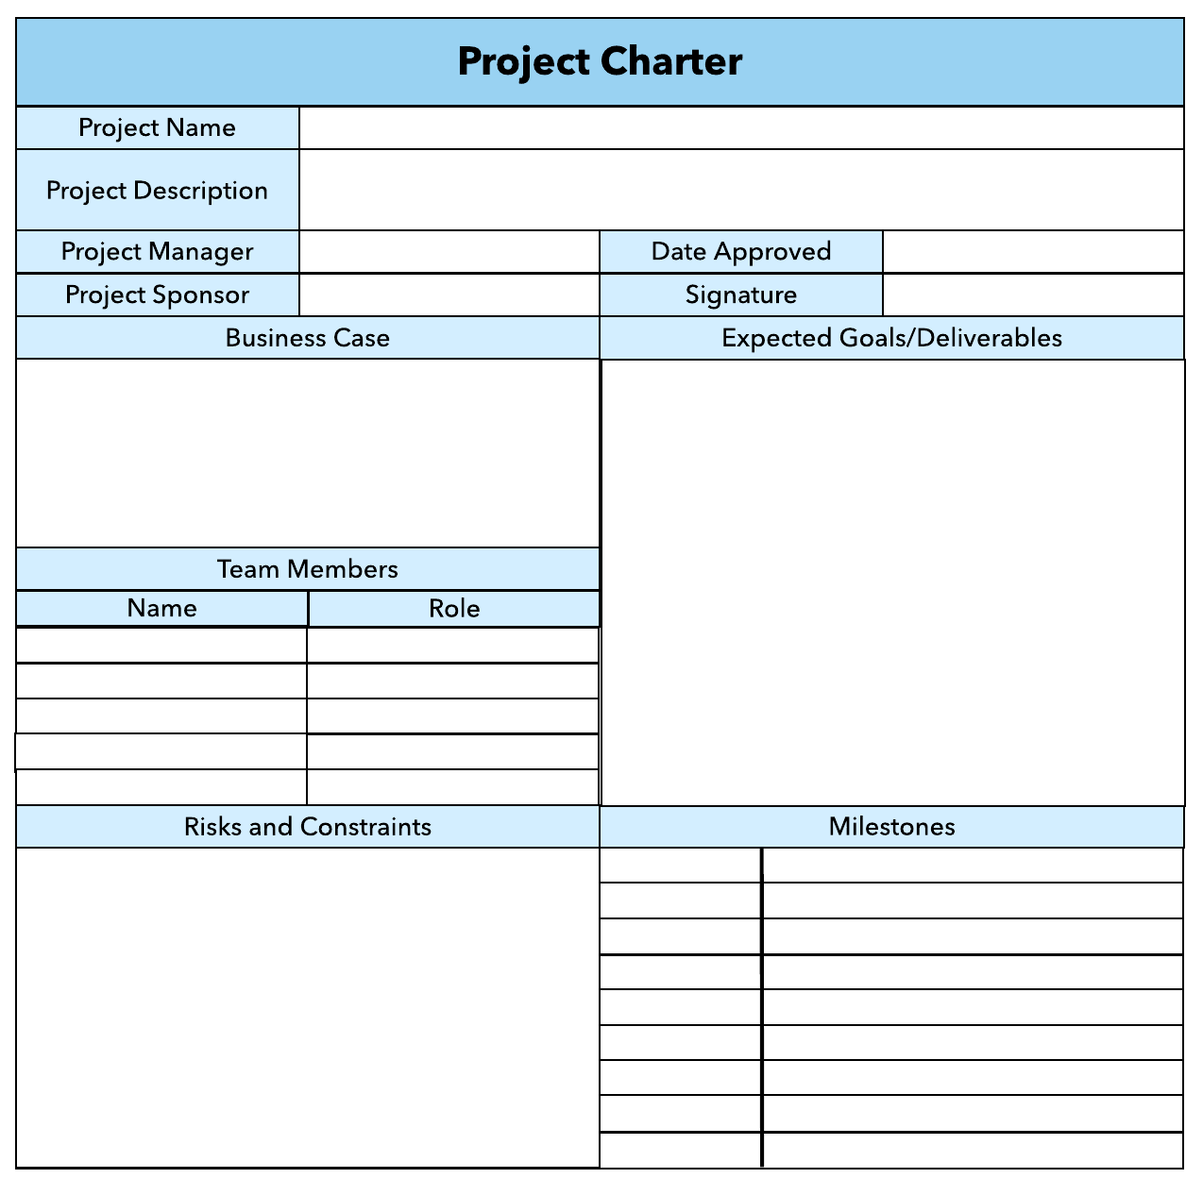What advice do we give about factoring in the commitments of project stakeholders when making your own plans?
   1. Consult student timetables to see when they might be free to attend data collection sessions.
   2. Ask external organizations what the most convenient times would be for you to visit
   3. Neither of these

d) Both A and B

Comment: your plan needs your stakeholders know before implantation.

1. Which of the following are essential components of a GANTT chart used to plan your project?
   1. Your home telephone number
   2. Your supervisor’s home telephone number
   3. The email address for the chair of the ethics committee
   4. None of the above

Comment: in order to get right or good Gantt Char, you need keep concern time, cost, scope and quality. So will get the good requirement and write good Gantt Char.

Web ref: <https://www.proofhub.com/articles/gantt-charts>

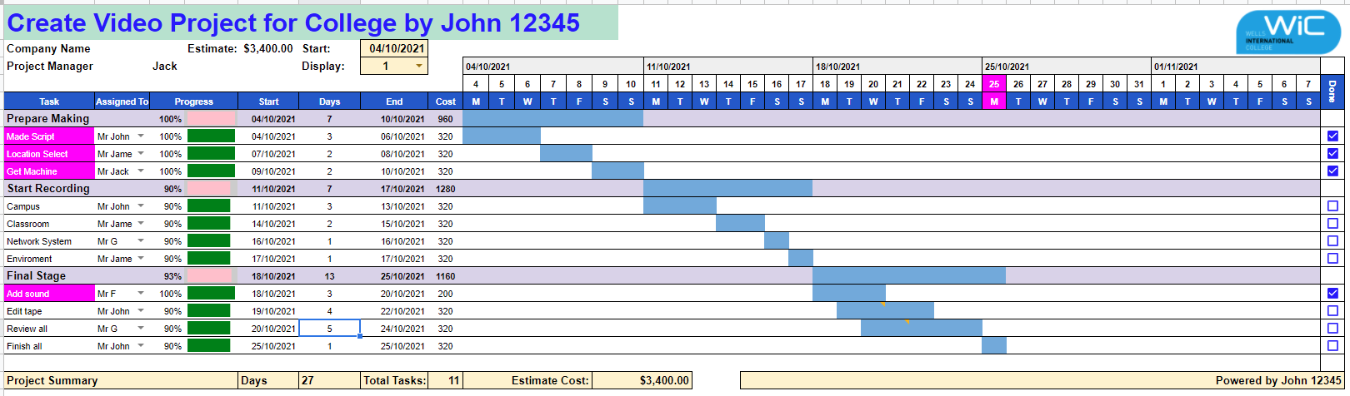

1. The intended outcome of strategy/projects integration is
   1. Clear organization focus
   2. Best use of scarce organization resources
   3. Improved communication across projects and departments
   4. Both A and C are correct
   5. A, B, and C are all correct



Comment: **Integration** management is a collection of processes required to ensure that the various elements of the **projects** are properly coordinated. It involves making trade-offs among competing objectives and alternatives to meet or exceed stakeholder needs and expectations.

Web Refer: <https://en.m.wikibooks.org/wiki/Project_Management/PMBOK/Integration_Management>

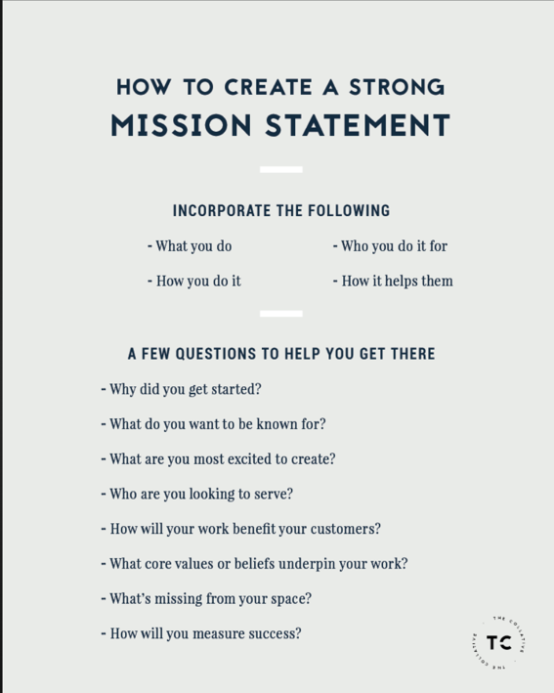

1. Which of the following questions does the organization's mission statement answer?
   1. What are our long-term strategies?
   2. What are our long-term goals and objectives?
   3. How do we operate in the existing environment?
   4. What do we want to become?
   5. All of these are answered by the mission statement

Comment: It is especially important for managers and executives in any organization to agree on the basic vision that the firm strives to achieve in the long term. An organization mission statement should answer the basic question, “What do we want to become?” A clear vision provides the foundation for developing a comprehensive mission statement

Web Refer: <https://phantran.net/vision-statements-what-do-we-want-to-become/>

1. 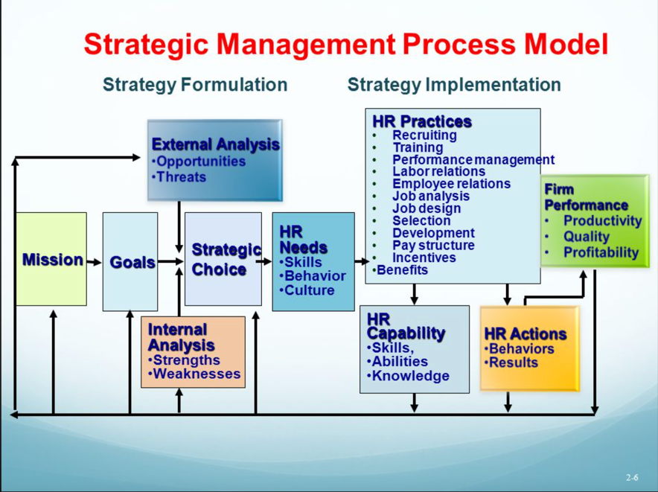Which of the following is not one of the requirements for successful implementation of strategies through projects?
   1. Allocation of resources
   2. Prioritizing of projects
   3. Motivation of project contributors
   4. Adequate planning and control systems
   5. All of these are requirements

Comment **So what can you do to maximize your chances of success and turn your vision into a business reality? 1.** SECURING ADEQUATE RESOURCES AND BUDGETS 2**. Prioritising Initiatives 3. Resource allocation (**Resources are a significant investment for most businesses.) 4. Motivation (Successful implementation demands cooperation from all functional and divisional managers in an organization. To this end, they must exchange notes freely, share resources in a spirit of give and take, take all people with them, monitor progress continuously, put everything on track and achieve results in a smooth way. All this calls for exceptional communication and motivational skills that help leaders to unite various powerful coalitions in an organization effectively.

Refer: https://www.cleverism.com/strategy-implementation-process/

1. Which of the following is the reason(s) why project managers need to understand their organization's mission and strategy?
   1. 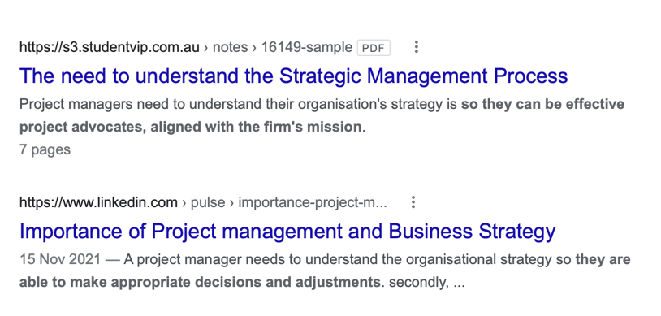To make appropriate decisions and adjustments
   2. To be effective project advocates
   3. To be able to get their job done
   4. Both A and B are correct
   5. A, B, and C are all correct

Comment: The first reason is that:- So, that the project managers can make appropriate decisions and adjustments, when responding to changes.  
- For example, how a project manager would respond to a suggestion to modify the design of a product to enhance performance *will vary*depending on whether his company strives to a product leader through innovation, or to achieve operational excellence through low-cost solutions. The second reason is that:-Project managers need to understand their organisation’s strategy is ***so*** they can be effective project advocates, aligned with the firm’s mission. For example, even during difficult times such as the changing of ownership.

Refer: https://s3.studentvip.com.au/notes/16149-sample.pdf

1. Which of these is the highest priority and first strategy required for any organizational change?

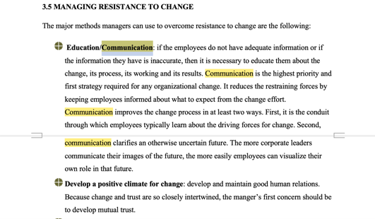a) Communication

* 1. Stress management
  2. Negotiation
  3. Learning
  4. Employee involvement

Comment: Communication is the highest priority and first strategy required for any organizational change. It reduces the restraining forces by keeping employees informed about what to expect from the change effort.

Refer: https://www.google.com/url?sa=t&rct=j&q=&esrc=s&source=web&cd=&ved=2ahUKEwj0u5rfu4f7AhX9y3MBHRaaC5UQFnoECAkQAw&url=http%3A%2F%2Fndl.ethernet.edu.et%2Fbitstream%2F123456789%2F79485%2F6%2Forganizational%2520change-CHAPTER%2520THREE.docx&usg=AOvVaw0-LaG8xf6Tcp7L8Iidfc6K

1. 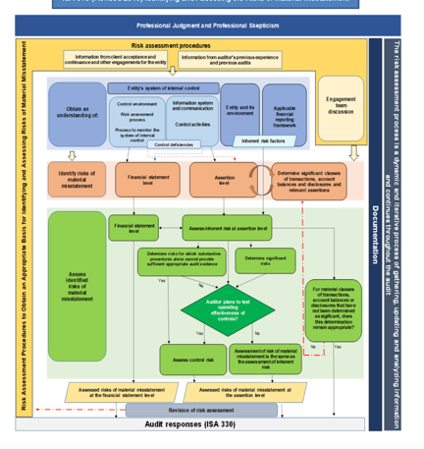Which of the following is not a procedure to obtain an understanding risk in the planning stage (described in ISA 315):
   1. Inquiries of management
   2. Analytical procedures
   3. Observation and inspection
   4. Procedures for sampling audit tests

Comment: procedures for sampling audits test is not in ISA 315, however, Inquires of management, Analytical procedures and observation and inspection are there

Refer: <https://leaccountant.com/isa-315-summary/>

1. Assessment of control risk includes three steps. Which of the following is not one of these steps?
   1. 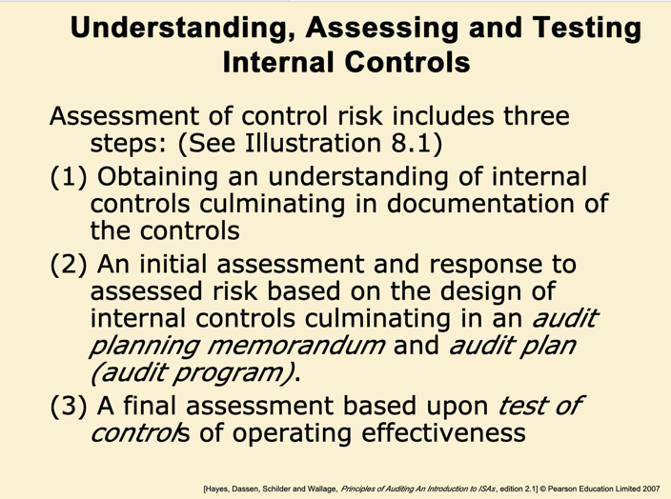Obtaining an understanding of internal controls and documentation of the controls
   2. Evaluate sufficiency and appropriateness of audit evidence
   3. An initial assessment and response to assessed risk based on the design of internal controls resulting in an audit planning memorandum and audit plan
   4. A final assessment based upon test of controls of operating effectiveness

Comment: An effective internal control system starts with the five components of internal controls listed in the COSO framework. In addition, comprehensive business planning and risk assessments reduce the risks to achieving business objectives while adhering to internal controls. These best practices guide the risk assessment process and the development of adequate internal control.

Refer: https://slideplayer.com/slide/7453086/

1. Which of the following are not common internal control documentation techniques used by auditors?

a) Questionnaires

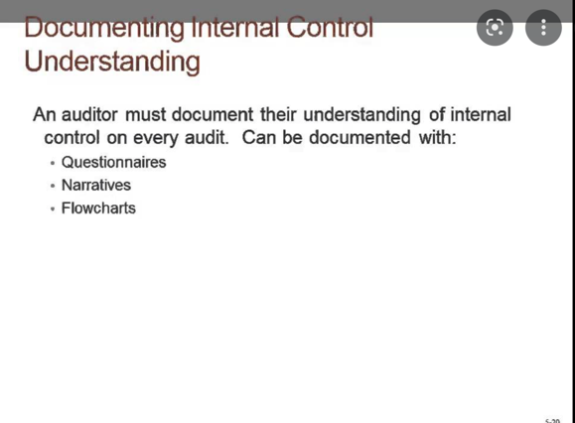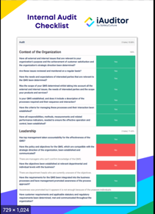

* 1. Company internal control manuals
  2. Narrative descriptions
  3. Check lists

Comment

**Documenting Controls**

 methods of documentation: narrative descriptions, questionnaires and checklists, flowcharts, control matrix

Refer: https://s3.studentvip.com.au/notes/3140-sample.pdf

1. Overall response to assessed risk may include:
   1. Identify the absence of key controls (where controls are lacking)
   2. Identify existing controls
   3. 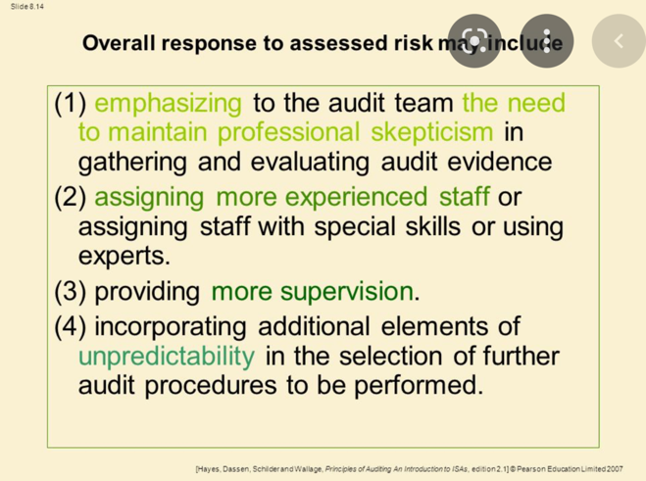Incorporating additional elements of unpredictability in the selection of further audit procedures to be performed
   4. Determine potential material misstatements that could result

*Comment:* Incorporating elements of unpredictability in the selection of audit procedures to be performed. As part of theauditor's response to the assessed risks of material misstatement, including the assessed risks of material misstatement due to fraud ("fraud risks"), the auditor should incorporate an element of unpredictability in the selection of auditing procedures to be performed from year to year. Examples of ways to incorporate an element of unpredictability include

Refer: https://pcaobus.org/oversight/standards/auditing-standards/details/AS2301

1. 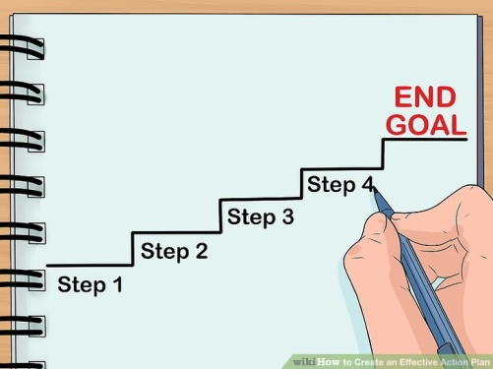Action plan Should be
   1. Specific
   2. Countable
   3. Realistic
   4. Achievable

Comment: An **action plan** is a detailed **plan** outlining actions needed to reach one or more goals. Alternatively, businessdictionary.com defines an **action plan** as a "sequence of steps that must be taken, or activities that must be performed well, for a strategy to succeed".

Web Refer: <https://en.wikipedia.org/wiki/Action_plan>

1. Which of the following is not a function of Project Management Tool?
   1. 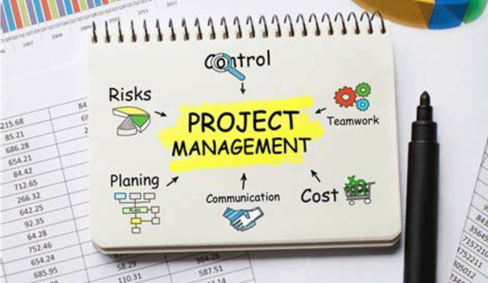Plan a project
   2. Manage Tasks
   3. Manage Issues
   4. Time Tracking
   5. Non of above

Comment: Project management tools are specially designed to assist an individual or team in organizing and managing their projects and tasks effectively. The term PM toolsusually refers to project management software and project management.

Refer: https://www.wrike.com/project-management-guide/faq/what-are-project-management-tools/

1. John, the project manager for the ERP Project, is about to complete the project phase review. The completion of a project phase is also known as which of the following? a) A lesson learned
   1. 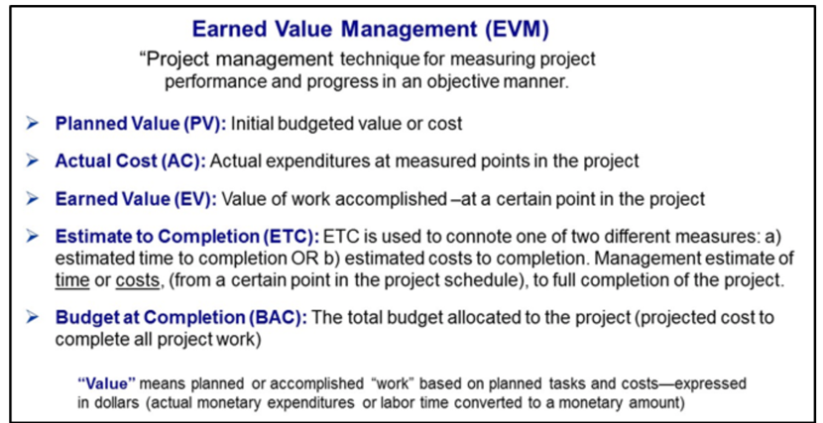A kill point
   2. Earned value management
   3. Conditional advancement

Comment: **Earned value management (EVM)** is an effective technique for tracking costs and examining project expenditures relative to completed work. Its strength is that it looks at cost, time, and task completion within the scope of the project simultaneously. It uses a WBS and budget created during the development stage, but tracks these metrics during the implementation stage of a project life cycle.

Refer: https://www.e-education.psu.edu/geog871/l6_p6.html

1. 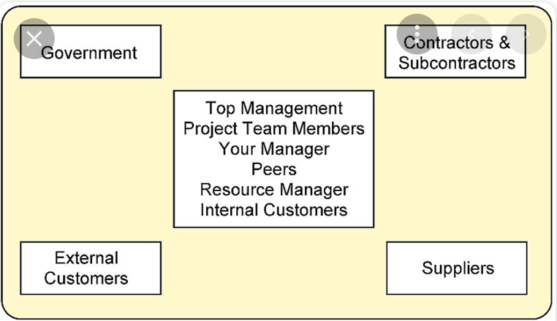Which of the following is not a key stakeholder in a project that creates a service internal to an organization?
   1. The project manager
   2. External customers
   3. Project vendors
   4. Project team members

Comment:  Project stakeholders. In a project, there are both internal and external stakeholders. Internal stakeholders may include top management, project team members, your manager, peers, resource manager, and internal customers.

Refer: https://opentextbc.ca/projectmanagement/chapter/chapter-5-project-stakeholders-project-management/

1. Managing a project is best described as which one of the following?
   1. Establishing direction
   2. Functional controls over the project team and stakeholders
   3. Consistently producing key results expected by stakeholders
   4. Motivating and inspiring the project team to produce results that are expected by project stakeholders

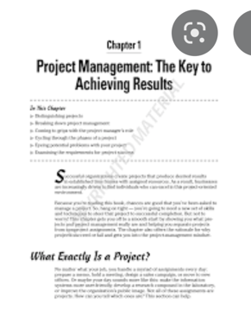Comment: a project is successful when it achieves its objectives and meets or exceeds the expectations of the stake­holders. So, the key result for managing a project is to produce the result constantly.

Refer: https://opentextbc.ca/projectmanagement/chapter/chapter-5-project-stakeholders-project-management/

1. You are the project manager for your organization. Influencing your organization requires which of the following?
   1. An understanding of the organizational budget
   2. Research and documentation of proven business cases
   3. An understanding of formal and informal organizational structures
   4. Positional power

Comment: The formal chain of command also keeps work processes under your control, because there is an established method of decision-making and implementation of your directives. The major advantage of an informal organizational structure is that it's highly adaptable to change.

Refer: https://smallbusiness.chron.com/basic-types-organizational-structure-formal-informal-982.html

1. What is the difference between a standard and a regulation?
   1. Standards are mandatory; regulations are not.
   2. Standards are optional; regulations are not.
   3. Regulations and standards are essentially the same.
   4. Regulations are usually mandatory; standards may be seen as guidelines.

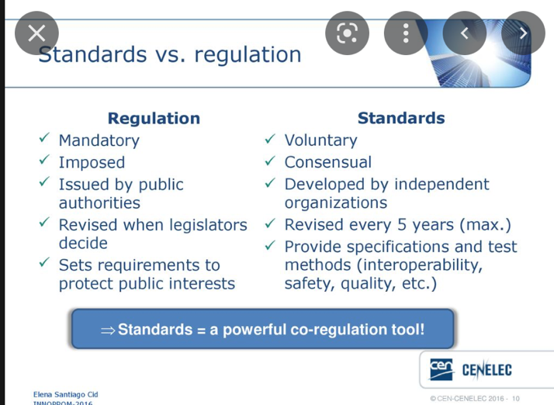

Comment: However, standards aren't the same as regulations and following a standard doesn't guarantee that you're within the relevant laws. In fact standards rarely cite the law as legislation could change within the lifetime of the standard.

Refer: https://www.bsigroup.com/en-GB/standards/Information-about-standards/standards-and-regulation/

1. Which of the following is an example of a deliverable at the end of the requirements-gathering phase in a software design project?
   1. 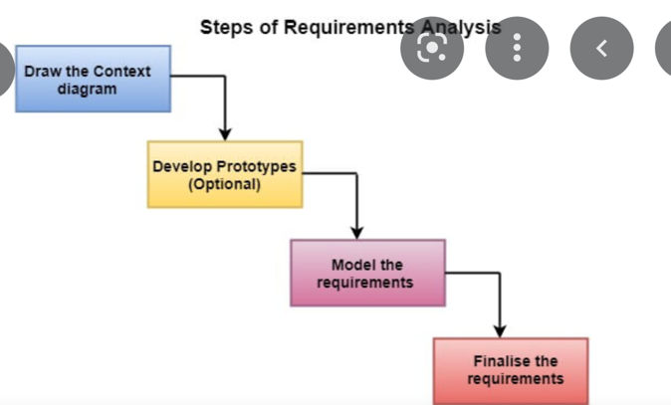Responsibility matrix creation
   2. Detail design document
   3. Business needs
   4. Project team assembled

Comment: When all the stakeholders have approved the set of requirements, we will know all the business needs on the project.

Refer: https://kissflow.com/project/steps-to-create-successful-project-plan/

1. At what point in a project would a kill point be acceptable?
   1. When a project team member is not performing as planned
   2. When a project reaches the end of a project phase
   3. When a project reaches the end of its budget
   4. 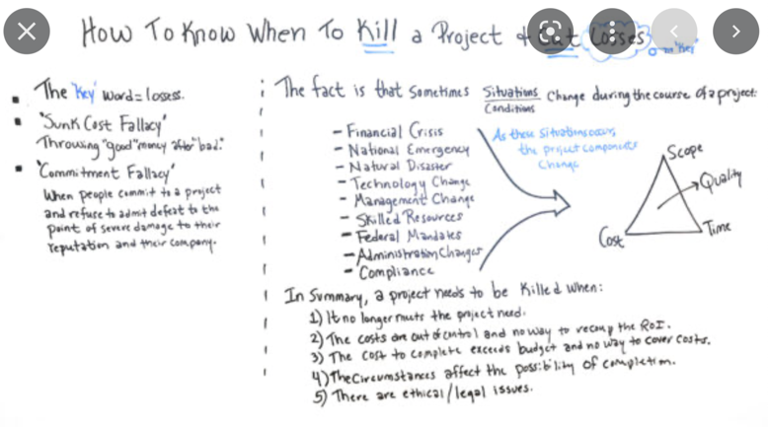When a project manager determines the project team cannot continue

Comment: Kill points are when the stakeholders decide that the project is not worth completing in its current state. It may be restarted with different criteria. Many projects are linked to the ongoing work of the performing organization.

Refer: https://certifedpmp.wordpress.com/tag/kill-points/

1. 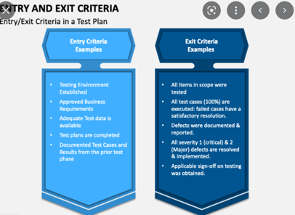Of the following, which is not an exit criterion?
   1. Customer sign-offs
   2. Quality metrics
   3. Stakeholder analysis
   4. Regulatory inspections

Comment: Exit criteria are the criteria or requirements, which must be met before completing a specific task or a process

Refer: <https://www.whatissixsigma.net/entry-and-exit-criteria/>

1. At which point is the risk of failure the least but the consequence of failure the highest?

a) During the early stages

* 1. During the middle stages
  2. 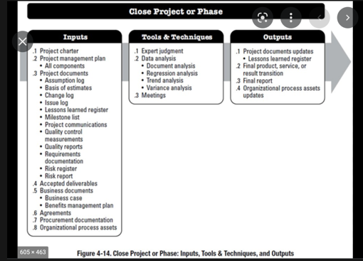During the final stages
  3. Risk of failure is even across all project phases

Comment: Most failure risk in the Closing stage is tied to earlier unaccounted-for issues that do not present themselves until the very end. For example, if you’re ready to send the project to key stakeholders for acceptance (i.e. close it out) but did not complete a formal scope or acceptance requirements review, then it’s possible that you won’t be able to successfully close off the project.

Refer: https://www.mentorworks.ca/blog/business-strategy/project-failure-risk-strategies/

1. In project estimation, project manager has to provide an expert judgement, which are considered of the following EXCEPT:
   1. Impact of inflation over the project lifecycle
   2. 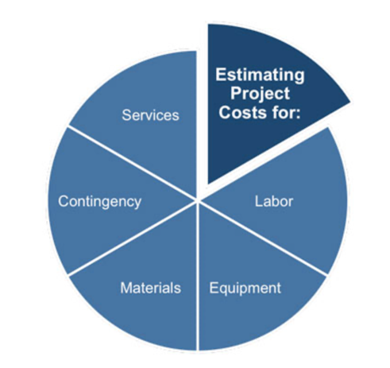Required labour and labour rates
   3. Material costs and assumptions
   4. Costs of quality
   5. All of above
   6. None of above

Comment : Cost estimates are influenced by numerous variables such as labor rates, material costs, inflation, risk factors and other variables. Expert judgment, guided by historical information, provides valuable insight about the environment and information from prior similar projects. Expert judgment can also be used to determine whether to combine methods of estimating and how to reconcile differences between them.

Refer: http://www.free-management-ebooks.com/faqpm/budget-02.htm

1. Which component is/are included in Quality Management Plan
   1. 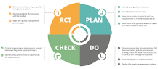Quality objectives
   2. Key project deliverables
   3. Quality standards
   4. Quality control and assurance activities
   5. All of above

Comment:

When broken down, quality control management can be segmented into four key components to be effective: quality planning, quality control, quality assurance, and quality improvement.

Refer: https://info.docxellent.com/blog/main-components-quality-management

1. What's an activity sequencing
   1. 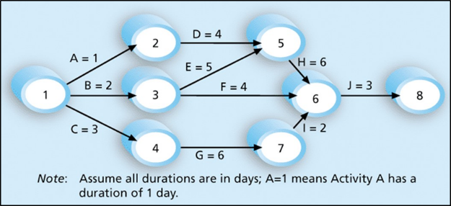The process for identifying and documenting dependencies among schedule activities
   2. The process for identifying critical activities
   3. The process for identifying ordering and schedule activities
   4. The process for planning the project

***Activity sequencing*** reviews all activities in the WBS with the goal of identifying relationships between them and classifying all the timing relationships among tasks. These relationships (aka "linkages", "dependencies", "predecessors"). Task timing relationships are important because they control task sequencing and task start and end dates. There are four types of task relationships:  
A ***finish-to-start relationship***

A ***start-to-start relationship***

A ***finish-to-finish relationship***

A***start-to-finish relationship***

Refer: <https://www.e-education.psu.edu/geog871/l5_p4.html>

Comment: activity sequencing could help make your project stage very clear and easy to follow the project progress. The process for identifying and documenting dependencies among schedule activities

## Learning Notes:

Project Management can benefit your professional and personal life. No matter which industry you end up in, understanding the basics of project management will always be in demand. Planning, budgeting, developing effective strategies, managing stakeholders, achieving tasks on a deadline and mastering the efficient management of time are all central to project management. When you study project management, you learn all the specific techniques, skills and programs you need to effectively manage your working schedule against a deadline. When you plan your projects well, you can foresee challenges to manage risks, prioritise accordingly and keep your eyes on the end goal. Instead of spending time staying afloat, you’ll be anticipating and riding the waves like a pro. When you study project management, you learn how each project can be broken down into a clear process of assigned tasks, milestones, and deadlines, and how to delegate each component to an assigned task manager to manage stakeholder expectations. This approach allows project manager to react to issues as they come up with greater agility and to direct their teams more effectively to deliver on strategy. As a result of learning project management, you will expect to gain skills as below:

* Analytical thinking and innovation
* Active learning
* Problem solving
* Critical thinking
* Leadership and social influence
* Reasoning, problem solving and ideation
* Resilience, stress tolerance and flexibility

## What is project?

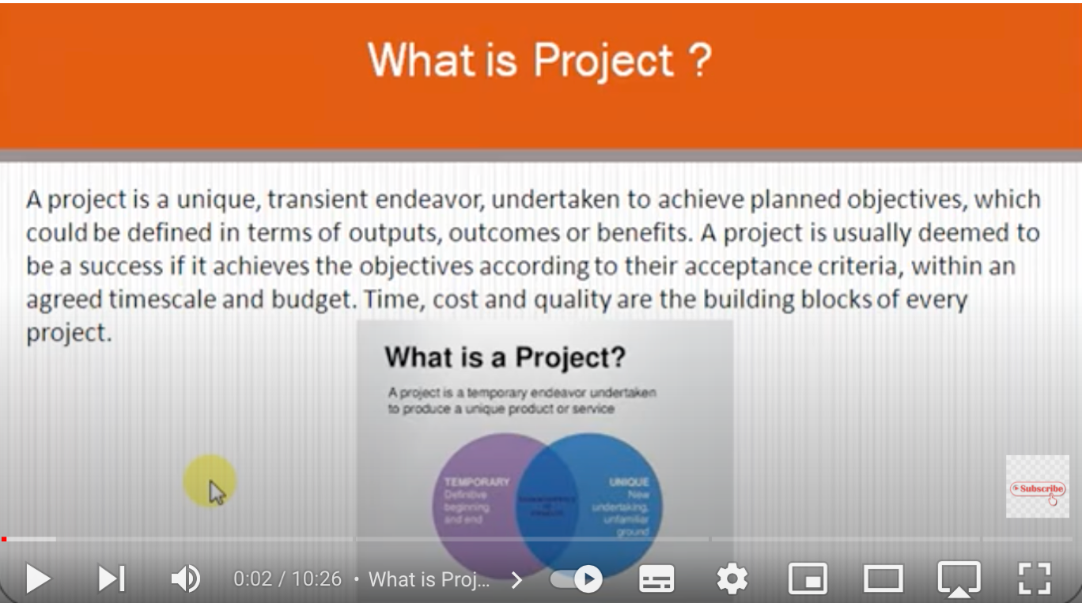

Refer: https://www.youtube.com/watch?v=_SOlpQfvT2c

## Please put your learning notes here:

A project is defined as a sequence of tasks that must be completed to attain a certain outcome. According to the Project Management Institute (PMI), the term Project refers to” to any temporary endeavour with a definite beginning and end”. Depending on its complexity, it can be managed by a single person or hundreds. A project can also be defined as a set of inputs and outputs required to achieve a particular goal. Projects can range from simple to complex and can be managed by one person or a hundred. Projects are often described and delegated by a manager or executive. They go over their expectations and goals, and it's up to the team to manage logistics and execute the project on time. Sometimes deadlines can be given. For good project productivity, some teams break it up individual tasks to manage accountability and utilize team strengths.

## Project management basic

Project management is the application of processes, methods, skills, knowledge and experience to achieve specific project objectives according to the project acceptance criteria within agreed parameters. Project management has final deliverables that are constrained to a finite timescale and budget.

## Project management History

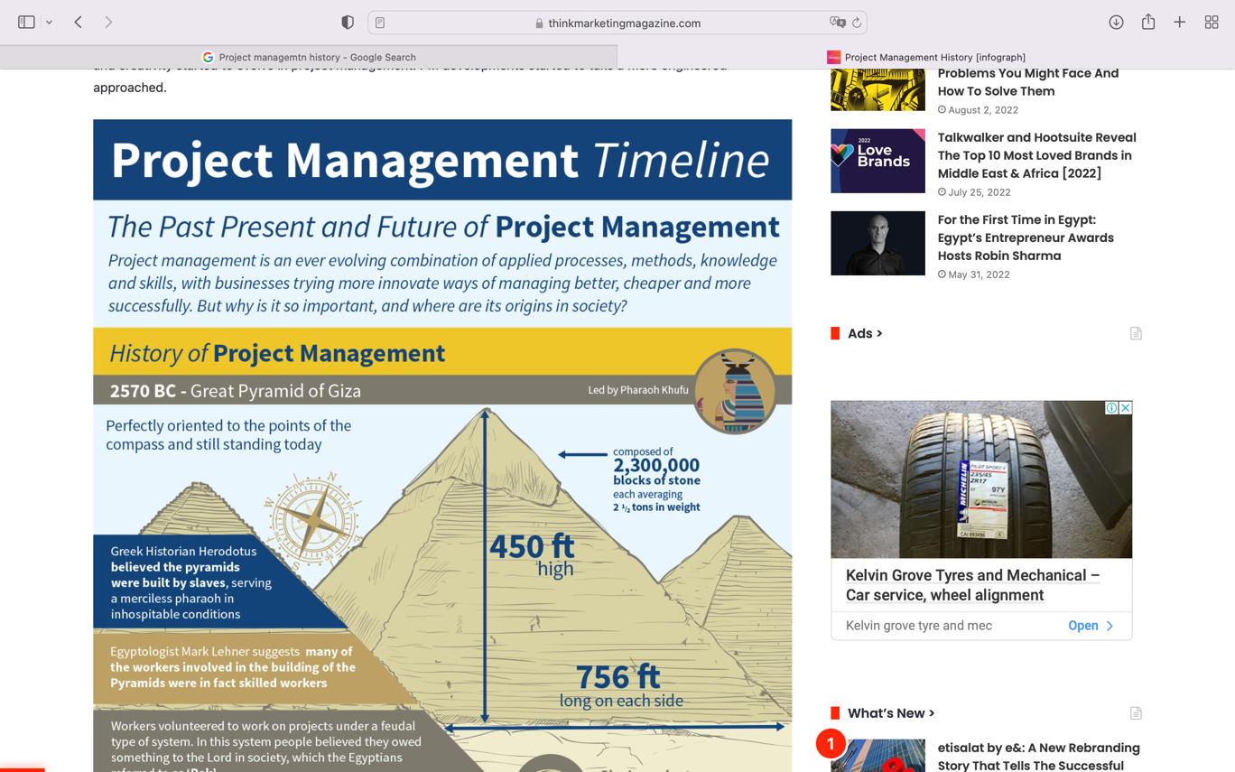

Looking at the earliest forms of project management, the Egyptians pioneered the concepts of project management. The Pharaohs who built the Great Pyramids at Giza did so through breaking down tasks into smaller chunks and dividing labour. Gangs of labourers were responsible for very specific aspects of the build meaning that they were able to complete the huge constructions before the death of the Pharaoh.

## Project management in the future

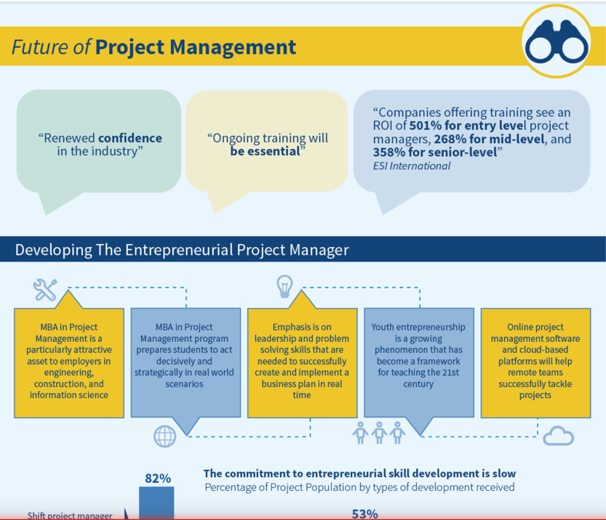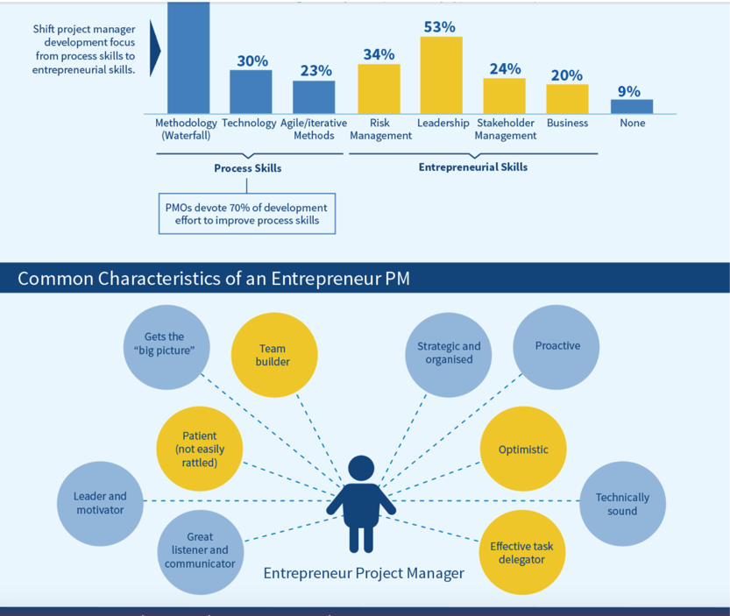

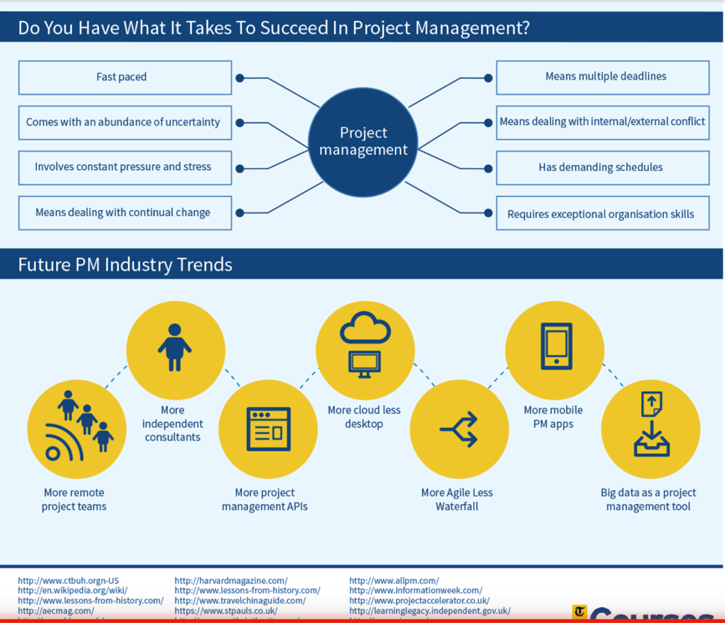

Some technological changes will also be forced on the project management profession by regulation. For example, the NSW Building Commissioner recently said, “Gone are the days where you will be able to be a Project Manager (for a building) from a Ute, using a mobile phone.” Regulation will require digital twins of buildings to be submitted to local governments. The digital model will provide a virtual environment to ensure the building is designed and engineered to a high standard and will become part of the planning process in the construction and infrastructure industries.

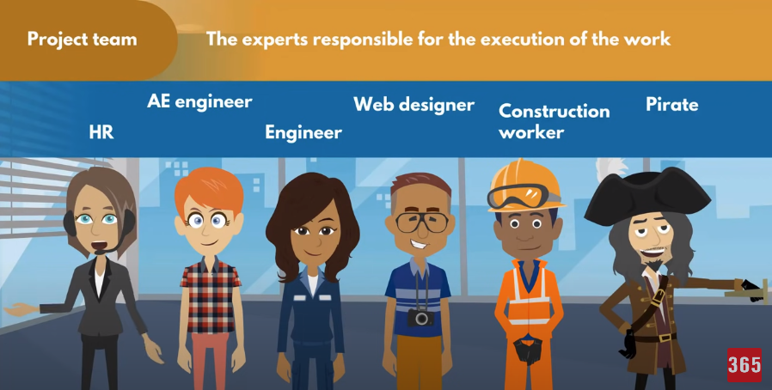

The experts responsible for the execution of the work

## Document Search Index

A

a GANTT chart 2

M

mission and strategy 3

mission statement 3

O

organizational change 3

P

project stakeholders 2

projects integration 2

S

successful implementation 3

U

understanding risk 4